
The Phase Mirror for Legal Governance

Executive Summary
The legal profession stands at a critical inflection point. By 2026, legal AI will shift decisively from experimentation to operational dependency, with firms expected to demonstrate not just adoption but governance, validation, and accountability. The American Bar Association's Formal Opinion 512 established that lawyers bear ultimate responsibility for AI outputs while maintaining "reasonable understanding" of AI capabilities and limitations. Meanwhile, the EU AI Act—with high-risk obligations taking effect in August 2026—classifies AI systems used in legal services as high-risk, with penalties reaching €35 million or 7% of global revenue.^{[1][2][3][4]}
This research study examines how the Phase Mirror methodology—an Agentic AI Governance module that specializes in surfacing productive contradictions, naming hidden assumptions, and converting them into concrete levers—can address the unique governance challenges facing legal practitioners, law firms, and corporate legal departments.
The Phase Mirror methodology does not resolve the inherent tension between AI autonomy and legal governance requirements—it names it. For legal practice, this means converting the structural friction between probabilistic AI outputs and binary compliance frameworks into manageable, auditable governance mechanisms.^{[5][6]}

The Legal AI Governance Challenge
The Convergence of Three High-Growth Markets
The legal sector sits at the convergence of three rapidly expanding markets: AI governance ($309M → $3.7B by 2033), AI compliance SaaS ($5B → $39.5B by 2034, 22.8% CAGR), and AI consulting services ($11B → $91B by 2035, 26.2% CAGR). Unlike existing GRC platforms that focus on compliance checklists, legal organizations require a diagnostic methodology that converts productive contradictions into actionable levers.^{[7]}
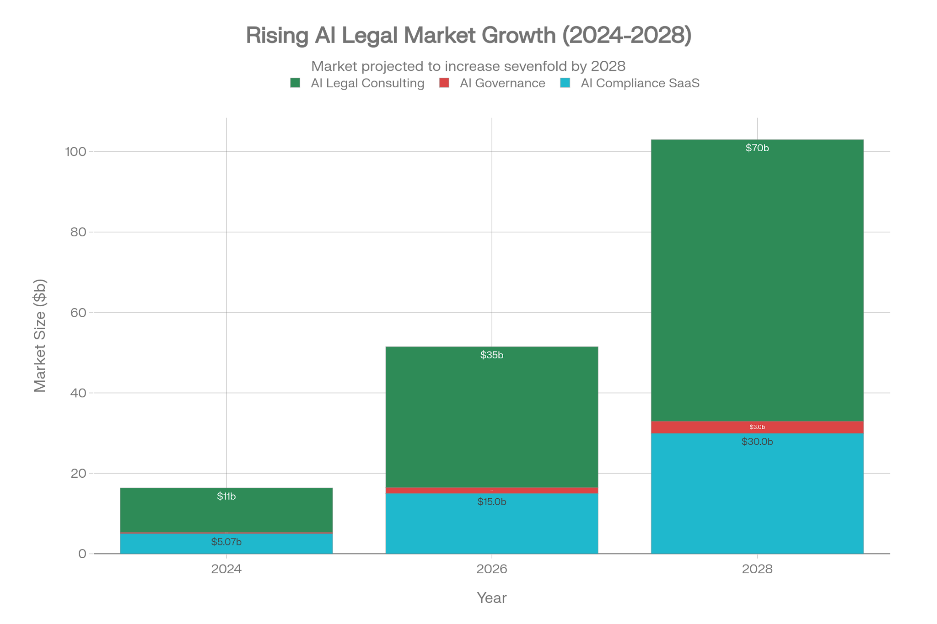
AI Legal Technology Market Projections (2024-2028) in Billions USD
The Fundamental Tension in Legal AI
Legal practice presents a uniquely challenging environment for AI governance. The profession operates under strict ethical obligations codified in the ABA Model Rules of Professional Conduct, where attorneys must exercise professional judgment, maintain client confidentiality, and bear personal responsibility for all work product. Simultaneously, AI systems promise unprecedented efficiency gains—54% of legal professionals now use AI for drafting correspondence, with document summarization (39%), editing (35%), and template drafting (32%) following closely.^{[3][8][9]}
This creates what the Phase Mirror methodology identifies as a permanent tension: AI systems produce probabilistic outputs based on statistical inference, while legal and compliance frameworks demand binary, pass/fail adherence. As one legal AI expert noted, "The differentiator may not be which AI a firm uses, but output validation. Human-in-the-loop workflows, QC, and defensible review processes will become core legal competencies".^{[5][6][1]}
Regulatory Pressure Intensifies
The regulatory landscape for legal AI governance is tightening across multiple jurisdictions:
Jurisdiction | Key Regulation | Effective Date | Impact on Legal AI
European Union | EU AI Act (High-Risk Provisions) | August 2, 2026 | Legal services classified as high-risk; conformity assessments required^{[2]}
United States | ABA Formal Opinion 512 | July 2024 | Establishes ethical framework for AI competence, confidentiality, supervision^{[3]}
Colorado | Colorado AI Act | June 2026 | First comprehensive U.S. state AI law; requires algorithmic discrimination prevention^{[10]}
Texas | TRAIGA (HB 149) | 2026 | State-level AI enforcement apparatus; $4M annual enforcement budget^{[11]}

Gartner projects that by 2026, 80% of organizations will formalize AI policies addressing ethical, brand, and PII risks. For legal organizations, governance has moved from best practice to compliance obligation.^{[2]}

Phase Mirror Methodology: Core Principles for Legal Governance
The Three-Part Diagnostic Framework
The Phase Mirror Dissonance (PMD) methodology breaks down into three concepts that create clarity from complexity:^{[12][13]}
Term | Definition | Application to Legal Governance
Mirror | Reflect claims without endorsement or judgment | Create neutral starting point for analyzing AI governance gaps in legal workflows
Dissonance | Identify underlying tensions, contradictions, or missing bindings | Expose hidden conflicts between AI capabilities and professional responsibility rules
Phase | Propose small, testable, incremental shifts | Convert complex ethics requirements into concrete, measurable compliance actions

The Five-Step PMD Operating Loop
The Phase Mirror methodology operates through a repeatable, structured process:^{[13]}
- Extract: Identify core components—stated goals, underlying claims, implicit fears, constraints, stakeholders, and time horizons
- Map Tensions: Analyze components to identify key contradictions (e.g., efficiency vs. verification duties)
- Rank Tensions: Prioritize using the formula: Impact × Tractability
- Produce Output Blocks: Generate Phase Mirror Dissonance (issues), Levers (interventions with owners, metrics, horizons), and Optional Artifact
- Pose Precision Question: Ask single clarifying question only if blocking ambiguity exists
Core Heuristic for Legal Governance
The methodology's core heuristic is particularly relevant for legal practice: Replace "align" with a binding artifact. For law firms implementing AI governance:^{[5][13]}
- Replace "we align on confidentiality" → Data Processing Agreement with specific AI vendor terms
- Replace "we collaborate on review" → Defined escalation protocol with decision thresholds
- Replace "we trust the AI" → Audit trail requirements and verification checkpoints

Legal Sector AI Governance Dissonances
Applying the Phase Mirror framework to legal AI systems reveals six critical dissonances that represent the primary sources of professional liability exposure.^{[5][6][13]}
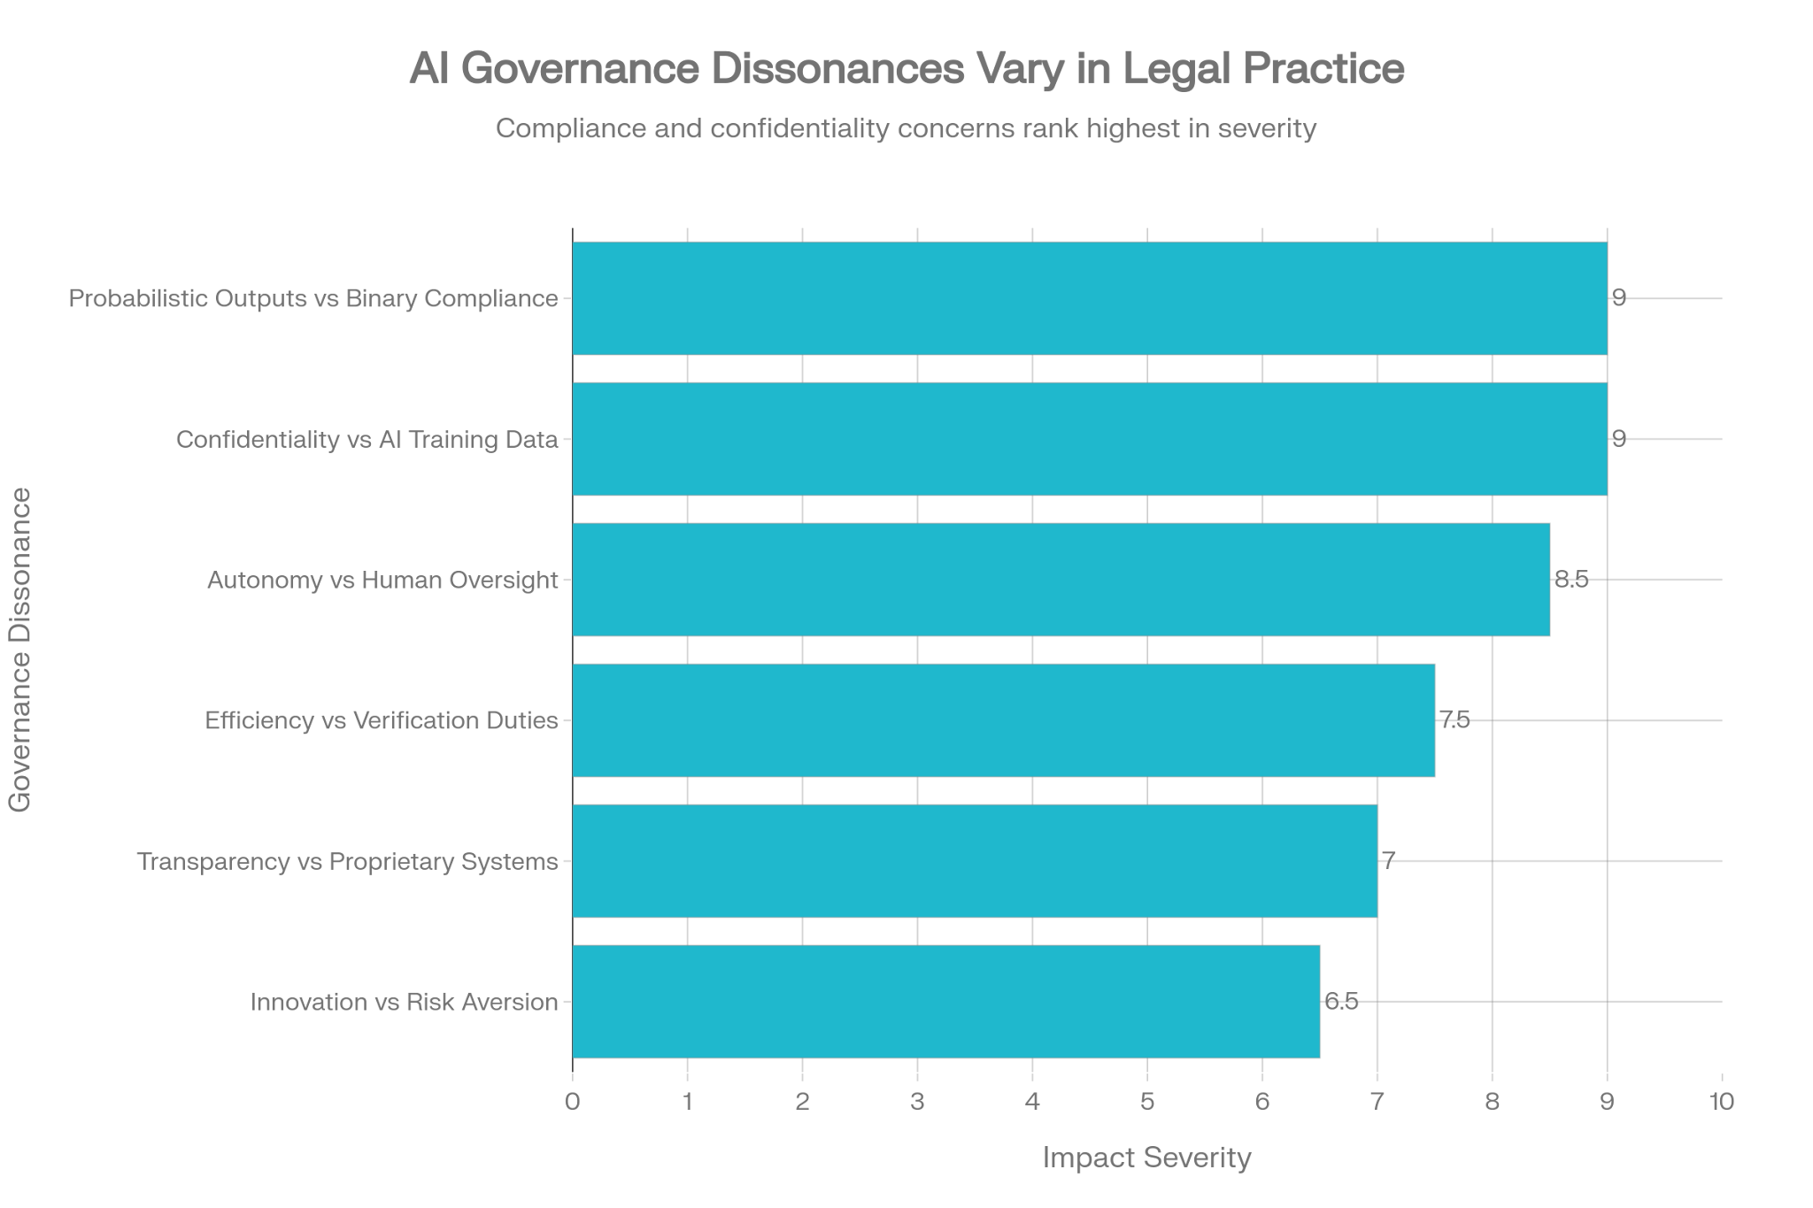
Critical AI Governance Dissonances in Legal Practice: Impact Severity Assessment
Dissonance 1: Probabilistic Outputs vs. Binary Compliance (Impact: 9/10)
AI systems produce probabilistic outputs based on statistical inference, creating fundamental friction with legal frameworks that operate on binary logic. When an AI legal research tool reports 87% confidence that a case supports a legal argument, attorneys must translate this into a definitive professional assertion.^{[5][6]}
Phase Mirror Lever:
Owner | Lever | Metric | Horizon
[General Counsel] | Define probability thresholds for AI outputs mapped to firm risk tolerance | Audit Pass Rate | 60 days

Dissonance 2: Confidentiality vs. AI Training Data (Impact: 9/10)
ABA Model Rule 1.6 requires lawyers to keep all client information confidential. Many AI tools, particularly "self-learning" systems, may use input data for training purposes, creating risks that confidential information could be disclosed to others. Opinion 512 mandates that attorneys obtain informed client consent before inputting confidential information into such tools.^{[3]}
Phase Mirror Lever:
Owner | Lever | Metric | Horizon
[IT/Compliance] | Implement AI vendor security assessment checklist with data retention and training data policies | Zero client data in training sets | 30 days

Dissonance 3: Autonomy vs. Human Oversight Requirements (Impact: 8.5/10)
The requirement for human oversight may be inherently incompatible with agentic AI systems designed to act autonomously. The EU AI Act (Article 14) requires high-risk AI systems to enable effective human oversight. For legal AI, meaningful human control might require pre-defined boundaries and kill-switches rather than real-time oversight—fundamentally limiting the autonomous capabilities that make these systems valuable.^{[14][15]}

Phase Mirror Lever:
Owner | Lever | Metric | Horizon
[Practice Group Leader] | Replace "human-in-the-loop" with "human-on-exception" protocol with defined triggers | Intervention Ratio ≤5% | 45 days

Dissonance 4: Efficiency Gains vs. Verification Duties (Impact: 7.5/10)
As of June 2025, 156 cases noted attorneys citing fake AI-generated cases, with sanctions as high as $24,000. Federal judges have imposed thousands in fines for AI-generated fabricated citations. The efficiency promise of AI conflicts directly with the attorney's duty to verify all outputs. Lawyers must exercise the same caution with AI-generated work as they would with work produced by a junior associate.^{[8][16][17]}
Phase Mirror Lever:
Owner | Lever | Metric | Horizon
[Managing Partner] | Implement mandatory verification protocol with audit trail for all AI-assisted court filings | 100% verification rate; 0 AI hallucinations filed | 21 days

Dissonance 5: Transparency Rhetoric vs. Proprietary Systems (Impact: 7/10)
Corporate rhetoric around AI transparency clashes with reliance on opaque, proprietary "black box" platforms. Law firms need visibility into how AI is developed to achieve defensible automated classification. Professional-grade legal AI tools offer 95% accuracy compared to consumer tools' 60-70% rates, but even professional tools may lack the explainability required for court proceedings.^{[5][16][18]}

Phase Mirror Lever:
Owner | Lever | Metric | Horizon
[Legal Ops] | Require explainability standards in all AI vendor contracts; implement audit-ready decision logs | 100% traceable AI decisions | 60 days

Dissonance 6: Innovation Pressure vs. Risk Aversion (Impact: 6.5/10)
Some legal experts argue that a blanketed refusal to use AI may conflict with ethical obligations under ABA Model Rule 1.1's competence requirement, which mandates lawyers stay current with "benefits and risks of relevant technology". Yet premature adoption without adequate governance creates malpractice exposure. Professional liability insurers are beginning to specifically exclude AI-related claims.^{[19][17]}
Phase Mirror Lever:
Owner | Lever | Metric | Horizon
[Risk Management] | Establish AI usage policy defining allowed, limited, and prohibited use cases by risk tier | Policy adoption rate 100%; insurance coverage confirmed | 30 days

Legal AI Use Cases for Phase Mirror Application
Use Case 1: Legal Research and Citation Verification
The Dissonance: AI promises rapid legal research but produces hallucinated citations. Morgan & Morgan lawyers learned a costly lesson when a federal judge imposed $5,000 in fines after an internal AI program "hallucinated" cases incorporated into a court filing.^{[16]}

Phase Mirror Application:
PMD Element | Application
Mirror | AI research tools promise 90%+ time savings on case research
Dissonance | AI hallucinations create malpractice exposure; no verification = "productive laziness"^{[19]}
Phase | Implement tiered verification protocol: AI flags → attorney review → supervisor sign-off

Binding Artifacts Required:
- Spec: Define acceptable AI research use cases vs. prohibited applications
- SLA: Establish internal response time for verification (e.g., 24hr for routine, 4hr for urgent filings)
- Kill-switch: Automatic escalation if AI confidence score falls below threshold
Use Case 2: Contract Review and Due Diligence
The Dissonance: AI contract review can process thousands of documents in hours, but risk assessment outputs require translation into actionable legal conclusions.
Phase Mirror Application:
Legal document automation reduces time spent on document-related tasks by 50% overall. AI systems can automatically identify clauses, potential risks, and inconsistencies faster than human reviewers. However, these audit trails must provide defensibility and demonstrate due diligence in professional responsibility contexts.^{[20][21]}
Levers to Test Now:
Owner | Lever | Metric | Horizon
[M&A Partner] | Implement AI-assisted contract review with human oversight checkpoints | Review time reduced 50%; error rate maintained ≤0.1% | 45 days
[Legal Ops] | Deploy audit trail system for all AI-assisted document review | 100% traceability of AI vs. human review decisions | 30 days

Use Case 3: eDiscovery and Litigation Support
The Dissonance: eDiscovery is now the most trusted AI application in legal, with 95% of respondents expressing medium to high trust. However, perceived AI effectiveness has slightly declined, with more respondents rating solutions as "ineffective" compared to prior years.^{[18]}
Phase Mirror Application:
The accountable methodology requires transparent processes including inputs and outputs—legal teams need visibility into how AI achieves defensible automated classification. Given the sensitivity of legal data, data privacy, compliance, and security must be top priorities.^{[18]}
Governance Framework Binding:
- Spec: Define privilege review accuracy thresholds (target: ≥95%)
- Contract: Establish vendor liability for discovery errors
- Dataset: Require validation of AI model training data provenance
Use Case 4: Agentic AI for Legal Operations
The Dissonance: By 2026, agentic AI systems capable of autonomous planning and execution will be common in legal workflows, but tightly constrained. The shift from prediction to action moves liability from end-user to system designer.^{[5][1][15]}
Phase Mirror Application:
The Phase Mirror methodology demands answering the Precision Question: Does the agent optimize for the most accurate outcome or the most compliant one? This cannot be answered abstractly—it must be encoded as policy.^{[13][5]}

Binding Artifacts:
Artifact Type | Legal Application
Spec | Define "acceptable" agentic AI errors vs. policy violations
Contract | Establish liability tiers between firm and AI platform providers
SLA | Commit to specific audit pass rates and explainability standards
Kill-switch | Governance triggers for agentic AI operating outside defined parameters

Implementation Framework for Legal Organizations
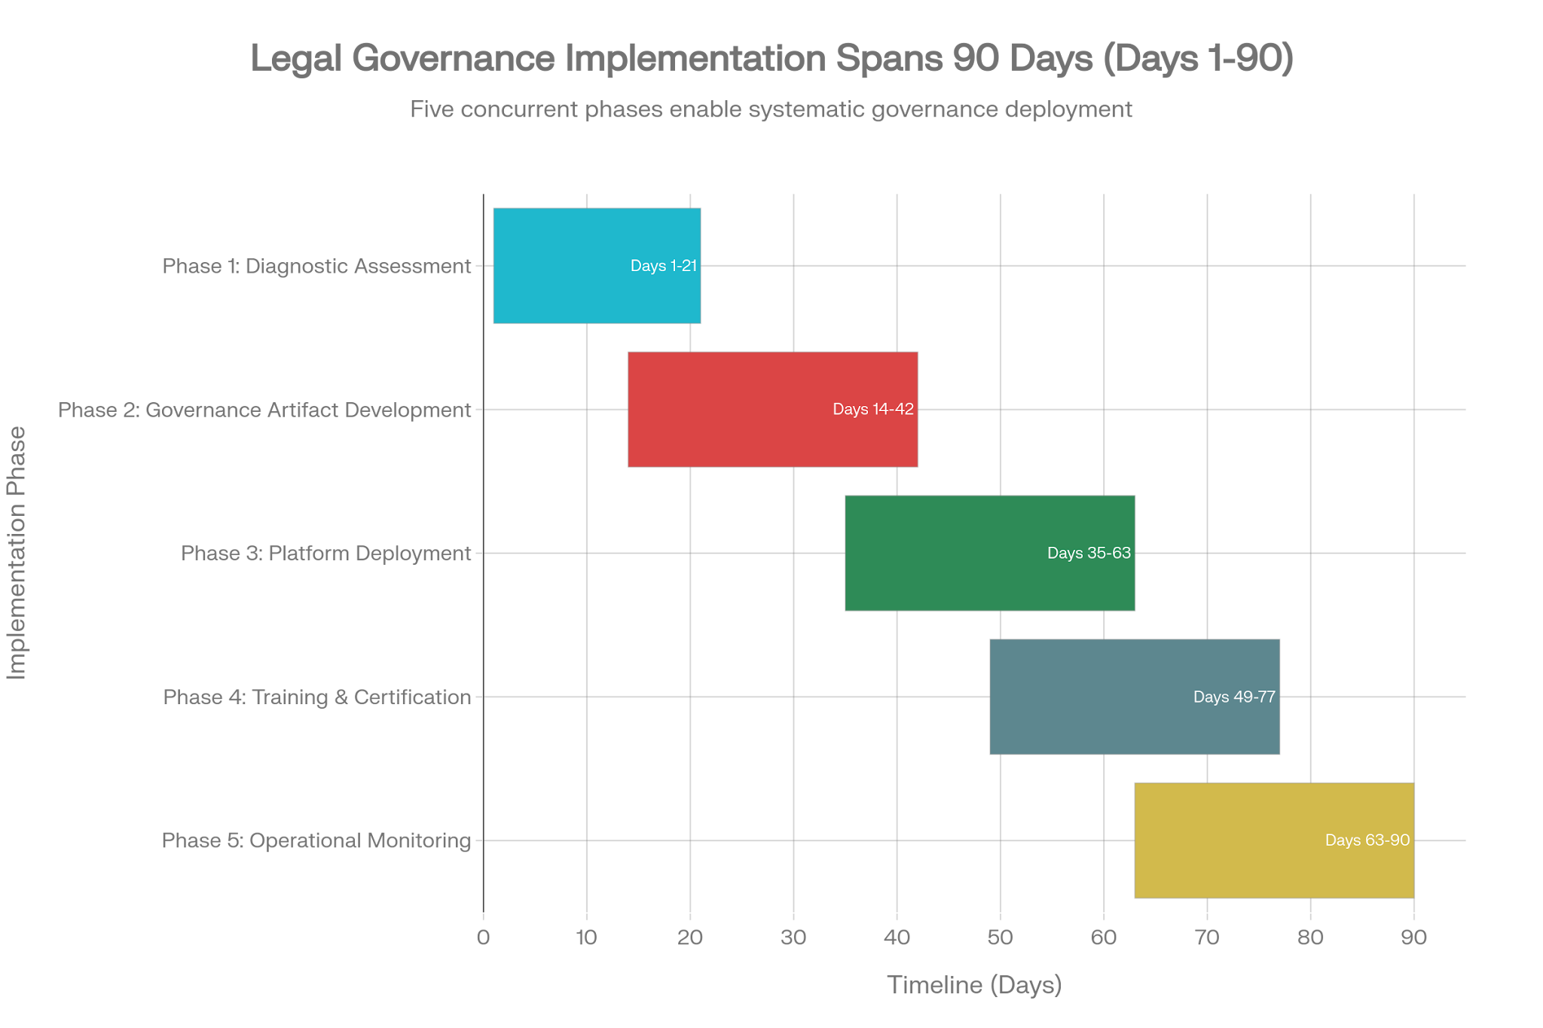
Phase Mirror Legal Governance Implementation Roadmap (90-Day Timeline)
Phase 1: Diagnostic Assessment (Days 1-21)
Objective: Surface productive contradictions between AI adoption goals and professional responsibility requirements.
Activities:
- Executive discovery sessions with practice group leaders, general counsel, risk management
- AI system inventory across all practice areas
- Tension mapping using PMD methodology
- Risk heat map development
Deliverables:
- Ranked dissonance matrix with Impact × Tractability scores
- Stakeholder interview synthesis (5-8 sessions)
- Current state assessment of AI usage patterns
Phase 2: Governance Artifact Development (Days 14-42)
Objective: Create binding artifacts that translate Phase Mirror methodology into enforceable governance.
Activities:
- Draft AI usage policy aligned with ABA Opinion 512 requirements
- Develop verification protocols for AI-assisted work product
- Create audit trail specifications
- Design exception handler procedures
Deliverables:
Artifact | Purpose
AI Usage Policy | Define allowed/limited/prohibited use cases by risk tier
Verification Protocol | Step-by-step review process for AI outputs
Liability Contracts | Vendor agreements with AI-specific provisions
Kill-Switch Protocols | Escalation triggers and rollback mechanisms

Phase 3: Platform Deployment (Days 35-63)
Objective: Deploy Phase Mirror Oracle integrated with legal technology stack.
Integration Points:
- Document management systems (iManage, NetDocuments)
- Practice management software
- eDiscovery platforms
- Contract lifecycle management tools
Technical Requirements:
- SSO/SAML integration
- Audit log export capabilities
- API access for custom rule development
- Compliance pack deployment (Legal Services Pack)
Phase 4: Training & Certification (Days 49-77)
Objective: Build certified expertise in Phase Mirror methodology across legal staff.
Training Curriculum:
Course | Audience | Duration
PMD Foundations | All legal staff | 8 hours (self-paced)
AI Governance for Legal Practice | Practice group leaders | 2 days
Certified Phase Mirror Practitioner (CPMP) | Compliance officers, senior associates | Exam-based

Phase 5: Operational Monitoring (Days 63-90)
Objective: Establish continuous governance with metrics and feedback loops.
Key Metrics:
Metric | Target | Measurement Frequency
AI verification compliance rate | 100% | Daily
Hallucination incidents | 0 | Per filing
Audit trail completeness | 100% | Weekly
Policy violation rate | <0.5% | Monthly
Training completion rate | 100% | Quarterly

Compliance and Liability Management
Mapping Probabilistic Outputs to Liability Tiers
The Phase Mirror methodology requires explicit mapping of AI confidence scores to legal risk categories:^{[5][6]}
AI Confidence Level | Risk Tier | Required Human Review | Documentation Requirement
≥95% | Low | Spot-check (10%) | Standard audit trail
80-94% | Medium | Full review required | Enhanced documentation
60-79% | High | Senior attorney verification | Risk acknowledgment form
<60% | Critical | Do not use; escalate to human research | Incident report

Professional Liability Insurance Considerations
Professional liability insurers are beginning to attach endorsements limiting coverage for AI use without fact-checking. Attorneys should not expect malpractice insurance to cover claims based on fraudulent billing tied to AI use. Phase Mirror governance artifacts provide the documentation trail necessary to demonstrate reasonable care.^{[19][22]}
Regulatory Alignment Framework
Regulatory Requirement | Phase Mirror Mechanism
ABA Rule 1.1 (Competence) | Training certification; AI capability assessment
ABA Rule 1.6 (Confidentiality) | Data governance controls; vendor assessment checklist
ABA Rule 3.3 (Candor) | Verification protocol; audit trail
ABA Rules 5.1/5.3 (Supervision) | Exception escalation procedures; human oversight checkpoints
EU AI Act Article 14 (Human Oversight) | Kill-switch protocols; human-on-exception design

Governance Levers for Legal Practice: Summary Action Plan
Owner | Lever | Metric | Horizon
[General Counsel] | Establish AI Governance Committee with cross-functional membership | Committee chartered, meeting monthly | 21 days
[Managing Partner] | Adopt firm-wide AI usage policy aligned with ABA Opinion 512 | 100% partner approval | 30 days
[IT/Security] | Implement AI vendor security assessment with data retention and training policies | 100% vendor compliance | 45 days
[Risk Management] | Map AI confidence outputs to liability tiers with required verification levels | Framework documented and deployed | 30 days
[Practice Group Leaders] | Deploy verification protocols for all AI-assisted client work | 100% compliance; 0 hallucinations | 60 days
[Legal Ops] | Implement audit trail system for AI-assisted workflows | Complete traceability for all AI decisions | 45 days
[HR/L&D] | Launch AI governance training curriculum with certification track | 100% staff trained within 90 days | 90 days
[Compliance] | Establish continuous monitoring dashboard with incident response procedures | Real-time metrics; <1hr critical response | 60 days

Conclusion: From Dissonance to Deliberate Legal Governance
The contradictions inherent in deploying AI within legal practice are not problems to be solved but tensions to be managed. The most valuable skill emerging in 2026 is not AI proficiency alone but problem framing and workflow design—understanding how to diagnose challenges, select appropriate tools, decide what can be automated, and identify where human judgment remains essential.^{[1]}
The Phase Mirror methodology provides legal organizations with a structured framework for this navigation. Its core insight—replacing "vibe claims" with binding artifacts—aligns precisely with the legal profession's foundational requirement for documented, defensible processes.
The Precision Question for Legal Organizations:
Does the AI optimize for the most efficient outcome or the most professionally responsible one?
This question cannot be delegated to technology. It must be encoded as policy, with explicit triggers defining when professional responsibility overrides efficiency. When an AI system's output conflicts with verification requirements, the system must not produce unverified work product—it must escalate to a pre-defined human exception handler with logged rationale.^{[5][13]}
The Phase Mirror does not resolve the tension between AI capability and professional responsibility—it names it. For legal governance, naming these tensions explicitly, ranking them by impact and tractability, and converting them into auditable mechanisms is the path from hope-based AI adoption to governance by design.
Optional Artifact: "The attorney's signature is a promise that human judgment has touched every page."

This research study was prepared utilizing the Phase Mirror methodology documentation, ABA ethical guidance, regulatory frameworks, and current legal AI governance literature. Implementation should be coordinated with qualified legal counsel familiar with applicable jurisdictional requirements.
⁂

- https://natlawreview.com/article/85-predictions-ai-and-law-2026
- https://www.joneswalker.com/en/insights/blogs/ai-law-blog/ten-ai-predictions-for-2026-what-leading-analysts-say-legal-teams-should-expect.html?id=102lz7f
- https://www.fmglaw.com/professional-liability/aba-issues-formal-guidance-for-lawyers-use-of-generative-ai/
- https://brief.steno.com/legal-ai-rules-by-state
- Agentic-Domain-Specific-Reasoning.pdf
- Policy-Memo_-Managing-Agentic-AI-Liability-with-the-Phase-Mirror-Framework.pdf
- Phase-Mirror_-Consultation-SaaS.pdf
- https://legal.thomsonreuters.com/blog/generative-ai-and-aba-ethics-rules/
- https://www.mycase.com/blog/ai/best-ai-for-legal-writing/
- https://www.mindfoundry.ai/blog/ai-regulations-around-the-world
- https://www.texaspolicyresearch.com/ai-governance-is-shifting-from-legislatures-to-courts-and-bureaucrats/
- A-Clear-Guide-to-Phase-Mirror-s-Services.pdf
- Implementation-Guide_-Applying-Phase-Mirror-Dissonance.pdf
- https://www.okta.com/identity-101/agentic-ai-governance-and-compliance/
- https://www.joneswalker.com/en/insights/blogs/ai-law-blog/when-ai-acts-independently-legal-considerations-for-agentic-ai-systems.html?id=102kdl4
- https://legal.thomsonreuters.com/blog/how-consumer-ai-tools-create-hidden-malpractice-risks-for-law-firms/
- https://sandbergphoenix.com/ethical-obligations-and-artificial-intelligence-how-refusing-to-use-ai-in-legal-practice-may-be-inconsistent-with-certain-ethical-duties/
- https://www.lighthouseglobal.com/ai-in-ediscovery-report-2025
- https://www.reuters.com/legal/legalindustry/insuring-against-productive-laziness-attorney-use-artificial-intelligence--pracin-2025-12-22/
- https://doneforyou.com/how-to-automate-legal-document-review-with-ai/
- https://www.nexlaw.ai/blog/legal-document-automation-with-ai-transform-legal-workflows/
- https://www.l2insuranceagency.com/blog/legal-ai-hallucinations-and-your-attorney-malpractice-insurance-coverage/
- lets-analyse-the-open-core-pha-7FE_xGkPSKKRr2TerT0cjw.md
- lets-analyze-the-phase-mirror-kbBwuoY6QaWAaS93zZyABg.md
- License_-Strategic-Legal-Analysis.pdf
- The Phase Mirror does not resolve dissonance—it names it.pdf
- Understanding Phase Mirror Dissonance_ A Beginner's Guide.pdf
- The Phase of Mirror Dissonance.pdf
- Phase mirror dissonance___Open core must be useful.pdf
- Phase-Mirror_-Comprehensive-Services-Catalog.docx.pdf
- https://www.lyzr.ai/glossaries/ai-agent-compliance-frameworks/
- https://www.artificiallawyer.com/2026/01/08/artificial-lawyer-predictions-2026/
- https://www.mwe.com/industries/artificial-intelligence-law/
- https://airia.com/ai-compliance-takes-center-stage-global-regulatory-trends-for-2026/
- https://boomi.com/blog/agentic-ai-compliance/
- https://iapp.org/resources/article/global-ai-governance-jurisdiction-overviews
- https://www.bakerdonelson.com/2026-ai-legal-forecast-from-innovation-to-compliance
- https://www.squirepattonboggs.com/insights/publications/the-agentic-ai-revolution-managing-legal-risks/
- https://www.ncsl.org/technology-and-communication/artificial-intelligence-2025-legislation
- https://mylawcle.com/products/the-future-of-law-is-ai-including-ethical-considerations-2025-edition/
- https://www.uslegalsupport.com/blog/ai-governance-framework/
- https://legal.thomsonreuters.com/blog/ethical-uses-of-generative-ai-in-the-practice-of-law/
- https://www.debevoisedatablog.com/2024/08/05/guidelines-on-the-use-of-generative-ai-tools-by-professionals-from-the-american-bar-association/
- https://federal-lawyer.com/business-litigation/ai-litigation/professional-liability/
- https://www.ncbar.org/2026/01/13/beyond-the-ban-why-your-law-firm-needs-a-realistic-ai-policy-in-2026/
- https://aceds.org/generative-ai-in-law-understanding-the-latest-professional-guidelines-aceds-blog/
- https://www.michbar.org/journal/Details/ArticleID=5219
- https://complexdiscovery.com/weighing-ais-benefits-and-risks-in-litigation-and-ediscovery/
- https://fairnow.ai/free-ai-governance-framework/
- https://artofprocurement.com/blog/my-ai-governance-framework-for-procurement
- https://law.co/blog/legal-ai-audit-trails-designing-for-traceability
- https://www.epiqglobal.com/en-US/Resource-Center/Articles/How-AI-and-eDiscovery-Tools-Enable-Internal-Investigations
- https://www.sirion.ai/library/contract-negotiation/ai-contract-review/?topics=mas
- https://www.streamline.ai/tips/best-ai-tools-legal-compliance
- https://www.veritone.com/blog/transforming-legal-discovery-with-ai/
- https://legal.thomsonreuters.com/blog/buyers-guide-artificial-intelligence-in-contract-review-software/
- https://www.grantthornton.com/insights/articles/professional-services/2025/from-audit-trails-to-ai-trails-managing-service-firm-risks

